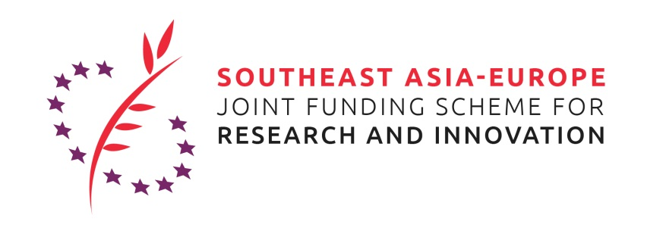

Call for Speakers:
Presentations for the SEA-Europe JFS 4th virtual Matchmaking Event following the Global Bioeconomy Summit 2020, for the 6th Joint Call for Proposals of Innovation in the thematic area of Bioeconomy, 23 November 2020
The selected applicant will present his/her project idea for a project proposal to be submitted under the 2020 Innovation Joint Call for Proposals of the Southeast Asia – Europe Joint Funding Scheme (JFS) (https://www.sea-eu-jfs.eu/calls) in the thematic area of Bioeconomy. In addition, the JFS team and partners will aim to support the organization of appointments with further potential project partners during the event.
The objective of the presentation is to identify partners from Southeast Asia and Europe for a project proposal.
The thematic area is Bioeconomy.
Deadline for submission of your application is on Monday, 16 November 2020, 11.59 pm CET; 5.59 am Jakarta Time.
Please note that the matchmaking event aims to facilitate the formation of bi-regional project consortia between Southeast Asian and European researchers.
The applicant will be informed if he/she was selected for the presentation on Tuesday, 17 November 2020.
The selected applicant will present his/her project idea in a 10 minutes slot at the JFS virtual Matchmaking event on 23 November 2020, which follows the Global Bioeconomy Summit 2020 in Berlin, Germany as a fully virtual event. The successful applicant will provide a file of slides for the presentation to the organizer of the event by 19 November 2020.
To apply please fill in all requested information of this form and send the filled application form and your CV by e-mail to: sea_eu_jfs@servicefacility.eu.

Personal data of presenter
Name, Surname:
Position:
Organisation/company:
Address (Street, postal code, town, country):
Email:
Telephone:
If applicant is a PhD-student, e-mail contact of supervisor/disciplinarian:

Application (max. 3 pages excl. CV)
Me:
- Shortly introduce your background and your current position
My institution:
- What institution/company are you working for?
- What are the main (research) areas/ business fields that the institution/company is active in?
- What are relevant projects your institution implements or implemented in the area of Infectious Diseases (incl. AMR)?
Our project idea:
- What is the thematic field of your project idea and what shall be done in the project?
- What is the international/bi-regional (Southeast Asia - Europe) aspect of the project?
- What is the innovative aspect of the project?
- Did you already identify other partners for the consortium? If yes, who are they?
- What would be your institution’s/company’s contribution to the project? What would be the contribution of other identified partners?
Your participation:
- What kind of partners are you still looking for? What type of organization/company, what expertise? What could be the partner’s contribution to the project?
CV
Please attach your CV to the application!

