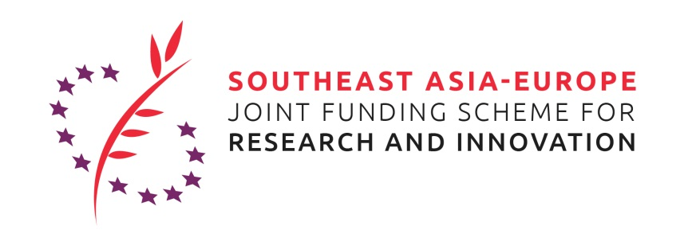
Application for:
Speaker at the 3rd Virtual JFS Matchmaking Event on health-related topics:
- “Infectious Diseases” (2020 S&T Joint Call)
- “Digital Health” (2020 Innovation Joint Call)

28 October 2020, 09:00 am CET / 15:00 pm Jakarta time
The selected applicant will present his/her project idea for a project proposal that shall be submitted under the 2020 S&T Joint Call for Proposals (Infectious Diseases) or the 2020 Innovation Joint Call for Proposals (Digital Health) of the Southeast Asia – Europe Joint Funding Scheme (JFS) (https://www.sea-eu-jfs.eu/calls). The objective of the presentation is to identify partners from Southeast Asia and Europe for a joint project proposal.
In addition to the presentation, the JFS management team and partners will aim to support appointments between the speaker and interested potential project partners from the audience.
The thematic areas are Infectious Diseases and Digital Health.
Deadline for application is Wednesday, 21 October 2020.
Please note that the matchmaking event aims to facilitate the formation of bi-regional project consortia between Southeast Asian and European researchers and innovators.
The applicant will be informed if he/she was selected for the presentation on Thursday, 22 October 2020.
The selected applicant will present his/her project idea in a 15 minutes slot at the 3rd Virtual JFS Matchmaking Event on 28 October 2020, which follows up to the World Health Summit 2020 in Berlin, Germany as a fully online event. The successful applicant will provide slides for the presentation to the organizer of the event by 27 October 2020.
To apply, please fill in all requested information of this form and send the filled application form and your CV by e-mail to: SEA_EU_JFS@servicefacility.eu (copy adele.clausen@dlr.de; tuan.bui@dlr.de).
For any question, please feel invited to contact us. It is our pleasure to support you!
SEA_EU_JFS@servicefacility.eu
adele.clausen@dlr.de; tuan.bui@dlr.de

Personal data of speaker
Name, Surname:
Position:
Organisation/company:
Address (Street, postal code, town, country):
Email:
Telephone:
If applicant is a PhD-student, e-mail contact of supervisor/disciplinarian:

Application (max. 3 pages excl. CV)
Please replace the italic by your respective contents
Me:
- Shortly introduce your background and your current position
My institution:
- What institution/company are you working for?
- What are the main (research) areas/ business fields that the institution/company is active in?
- What are relevant projects your institution implements or implemented in the area of Infectious Diseases (incl. AMR)?
Our project idea:
- What is the thematic field of your project idea and what shall be done in the project?
- What is the international/bi-regional (Southeast Asia - Europe) aspect of the project?
- What is the innovative aspect of the project?
- Did you already identify other partners for the consortium? If yes, who are they?
- What would be your institution’s/company’s contribution to the project? What would be the contribution of other identified partners?
Your participation:
- What kind of partners are you still looking for? What type of organization/company, what expertise? What could be the partner’s contribution to the project?
CV
Please attach your CV to the application!

